Business plan outline

Title page
Table of contents
Executive Summary
Business overview (Problem, purpose, solution)
The problem
Our solution
Our future
Market analysis
Market overview
Customer analysis
Competitors
Strategy / Business model
Market positioning
Management
Measuring results
Indicators of success
Milestones
Risk Assessment
Key issues that can block your progress / objectives
Financial plan
(optional) Appendix

Title page
Create a cover page with the following company / business information:
- Name of Company
- Address of Company
- City, State ZIP Code
- Telephone Number
- Fax Number
- Website
- Date of Plan Presentation

You may also include information on who you will present it to:
Presented to:
- Name
- Company

Include your own contact details:
- Name of Owner/Contact Person / group members
- Address
- City, State zip
- Telephone
- e-mail

Table of contents

Executive Summary
An executive summary is like any other summary in that their main goal is to provide a condensed version of your plan or report. However, the target readers of an executive summary are literally executives - persons with senior managerial responsibilities who most likely don't have the time to read the whole report. Not right away…unless you grab their attention.

The goal of the executive summary is to grab attention - to get the executives, managers, or investor/potential partner to read the business plan or to meet with you.
It's also important for you as entrepreneur to be able to distill the essence of your business down to its major points whether it's for an executive summary, a presentation, or a chance meeting with someone who might be able to grow your business.

Summarizing the essence of your business to a page (or no longer than 2-3 pages ideally) is helpful because you have to determine which aspects of your business have the clearest selling points and which may require more explanation. Do this as the last step of your report

The most important element to any executive summary is a clear, concise and relevant explanation of what your company does. You can use the following structure for your executive summary:

- Introduction: The first or introductory paragraph (or first few paragraphs) is very important. Ideally, readers should already be able to see the following information right away:
  - Company / business description
    - The kind of business you are
    - What stage of development is your business, e.g. development stage, first year, mature, etc.
  - The Problem
  - Your Solution (product/service)
    - Your main product or service
    - What needs it solves for your target customers (thus why they will buy it)
    - Your competitive advantage (what you do better than your competitors giving you a unique advantage)
  - Why Now (makes your business timely, and gives a sense of urgency to your executive summary).

After the introductory paragraph(s), you can summarize the following sections of the executive summary in the same order that is presented within the full business plan.

- Mission and objectives
  - Brief description of your vision for the future of your business
  - What are your short-term (within one year) and long-term (two to five years) objectives?
- Market analysis
  - Market potential - most important market information, e.g. industry, size, trends
  - Most important information or insight about your target customers
  - Most important information or insight about your competitors
- Strategy
  - Marketing plan: Your primary strategy for getting customers
  - Revenue / Pricing
- Organizational matters
  - The team: Brief description of the essential skills/expertise of the team that will contribute to the success of your business
  - Operations: what are the most important business processes you have to set-up in order to run your business?
- Measuring success
  - Primary conditions you must achieve for success to happen
  - Most important milestones (or business activities) you have to do to set up your business (if you are just starting), or implement the improvements you want.
- Financial planning
  - Bottom line - How much money do you (want to) have? How much does it take to run the business? How much will you earn (hopefully)?' Note: Specify the major costs.
  - Provide projected annual revenue and net income (ideally for five years)
  - If applicable to your situation: How will investors get their money back?

NOTE: Check out Arnel Cassanova’s presentation for more tips on writing an executive summary.

Business overview (Problem, purpose, solution)

The problem
- What’s the problem your business will solve and who are you solving it for?
  - Describe the main problem of your target customer and how they address this problem today.

Our solution
- What product or service are you offering that will make your target group's life better?
  - List down the main products and services and describe them. You can also use images in your explanation (e.g. photos, sketches, etc.).
  - Describe secondary products or services if applicable.
- How do your products/services address your customers' needs? (Refer to the customer reasearch you have done. )
- Why now? What makes your products/services timely and relevant (Refer to market overview and customer research.)

Our future
- What’s the future like for your business?
  - What is your mission? What is it that you will change? (Personal? social / community?)

Market analysis

Market overview
- What kind of business are you in or plan to go into?
  - Think of the specific market and/or industry that exists for your business E.g. Industries like IT sector, technology, commerce, healthcare; or markets for baby products, small business, migrant workers, etc...
- What’s the market size? (E.g. Total population in our municipality is X. Number of restaurants are X. Main target group 25+ y.o. population is X.)
  - How is the market segmented? (Fancy restaurants vs. carinderia vs. fast-food, etc. Delivery, vs. take-out only, vs. eat-in…)
- How is it changing? (Most important or exciting trends)
- How is it developing? (Is it growing or stagnant; are there innovations happening or is it lagging behind? )
- Who dominates it? (Key market players)
- What insights can you get from all the information you’ve researched?: E.g. Which market gaps can your business fill? What can you potentially do better? Which opportunities present themselves?

Customer analysis
- Describe your target customers. Below are some examples of the kind of information that might be relevant for your business. Please treat this as a guideline. Just focus on the information that can influence your strategy or business model. It’s not about how much information you can research for this sub-section, but how relevant the information is for your business.
  - Sex
  - Age
  - Income level / social class
  - Religion
  - Profession
  - Civil status
  - With/without kids / Average size of family
  - Values and beliefs
  - What is important for them in their personal life? Think of practical, educational, emotional, and other factors.
    - Teenagers look for identity, sense of belonging; low-income elderly people might want security and affection from family; higher-income elderly people may want to take on a new hobby or do volunteer work
  - What is important for them in their professional life?
    - Can be closely related or similar to what they want in their personal life, but there might be unique differences, too. E.g. A former stay-at-home mom who has just separated from her husband may want to take up online courses to refresh or enhance her skills because she wants to go back to work. So she’s on the lookout for products or services that help her improve herself. But a working mother who wants to get a promotion is on the lookout for products that can save her time (so she can do more work), such as ready-to-eat but home-cooked meals.
  - What are the main challenges they are facing? Think of their top 3 problems that you think are directly related to your market and business.

  - What influences their buying decisions?
    - Think of various factors like price, quality of product/service, value for money, popularity of brand, recommendations of friends and family, convenience, etc.
    - What drives them to buy from your competitor?
    - What stops them from buying from your competitor?

- What insights do these information reveal about your target groups?
  - Do they validate what you thought to be their main needs or problems that you can help them solve with your product or service?

Competitors
- Who are your main competitors?
- What are they doing good? Not so good?
- Insights: How can you compete with them using these information you know?
  - What are the gaps in their products or services that can serve as an opportunity for you?
  - How do / will you differ and stand out from them?

Strategy / Business model

Market positioning
A value proposition is a statement that explains what benefit you provide for your target groups and how you do it uniquely well. It describes your target customer, the problem you solve, and why you’re distinctly better than the alternatives. This positions your business against competitors and other key players in your market. This also serves as the starting point for your business strategy.

- What’s your unique value proposition?
  - Think of your competitive advantage? What do you do for your target market that is better than your competitor?
    - Note: Price may be a factor but a lower price is not always what makes you unique or what convinces a potential customer to choose you over others. It can be that people want your product because it’s unique so that may give you a competitive edge, but what if it’s something that easily can be substituted? Or in the case of a new product, being first in the market can be a USP, but having a product or service that can also be easily integrated with existing products can also be considered a good value proposition.

Marketing and promotion
Marketing is all about bringing your product or service in front of your target groups and creating relationships with them. (Get, keep, and grow customers.) Tip to help you focus: Think of the key activities or the initial activities you need to do to launch your business.

- How will you raise awareness and interest in your business?
- How will you convert prospects into customers?
- How will you keep them as customers?

[Optional] Growth strategy: Do you plan to grow by expanding your organization or your product/services? E.g. more stores, offering other/related services later on

Management
- Describe the organisational structure for this business.
- Who are the key members of the team, or who are the people you will need to have on your team?
  - What are their roles and expertise (e.g. technical, business), and do these match the goals of your business?
  - Will you need outside experts? Briefly describe the expertise you will need.
  - (Optional): What is your action plan to add the necessary talent needed for your business to attain its goal?

- What partnerships or alliances will you need?

Measuring results

Indicators of success
What are the conditions that need to happen for you to know that your business is on the road to success? This usually covers financial goals but can also include other business or organizational outcomes in marketing, product/service development, brand awareness, etc.

You may want to prioritize working on financial indicators of success as it is something you will need to define in your financial planning anyway. But you can also try to set other non-financial criteria, especially if you are a non-profit such as your foundation’s impact on your target beneficiaries.

[Note: The challenging part for setting non-financial goals is knowing how to measure it. For example, as a foundation focused on empowering women, how can you measure your positive impact on your target beneficiaries (if you consider that a measure of success)? How do you measure change in one’s values or beliefs? You can say that a proof of success is being able to get 10 women to finish a course on microfinancing (as you have identified financial stability as one way of empowering women). That’s not exactly proof that they will now be financially independent and believe in themselves, but you can infer from the fact that they finished the course, they will now be able to make more informed decisions on setting up and running a small business. The important point here is that success must always be measurable. if you cannot measure it, you cannot evaluate how your business is performing.]

- Example of success indicators: Reached target profits, increased target market, number of stores opened, number of products/services offered, percentage of repeat business/regular customers, brand loyalty developed, brand recognition, increase share in market

Success indicator (Objective) | Time
1. Reach break-even amount of X | Year 3
2. Increase target market by 10% | Every 6 months
3. Get 1000 subscribers in 3 months | Starting from launch date
4. Increase members of the cooperative by 30% | After 1 year
5. Conduct 12 literacy workshops | In 1 year
6. Provide 1 pig per household in the municipality | After 2 years

Milestones
What are the activities you have to do in order to start up and your business? Below are some examples:
- Market Research
- Business Plan
- Legal Documents
- Insurance
- Find Location, Rent
- Purchase Equipment
- Purchase Inventory &
- Materials
- Loan, Purchase Equipment
- Promotion & Business Sign
- Website creation
- Other Start-up Activities

Note: Include a time frame for these activities. See sample below.
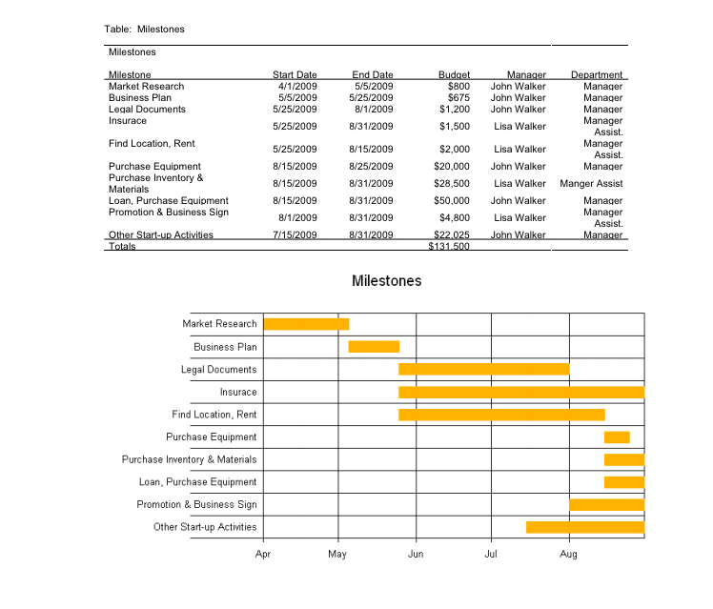

Risk Assessment

Key issues that can block your progress / objectives

Your plan can address several kinds of risk. You don't need to address every kind of risk in the book, but pick the risk categories that are most relevant to your company (and industry) and include a paragraph or two about each:
- Product risk is the risk that the product can't be created. E.g. Biotech firms never know for sure they can produce the drug they are hoping to produce.
- Market risk is the risk that the market will develop differently than expected. Sometimes markets take too long to develop, and cash runs out while a company is waiting for customers.
- People risk is big in companies that depend on having certain employees or certain kinds of employees. E.g. you need an expert to create a special type of furniture that you want to market. What would happen if you don’t get one on board your team?
- Financial risk is the risk that a company will run out of money or mismanage their money in some way. Finance companies may have huge financial risk, since bad lending policies combined with poor investment policies can sink them.
- Competitive risk is the risk that a competing product or service will be able to win. Many Web-based businesses have high competitive risk since they can be started with little money and have no way of locking in customers.
- Read more: http://www.entrepreneur.com/article/49042#ixzz2sdvGpgEN

For the purposes of this course, focus on identifying the major risks you face for launching your business and the first year of managing it. Below is a sample template. Don’t bother too much about the scoring. This is just meant to show you the things to consider when thinking of the risks for your business.

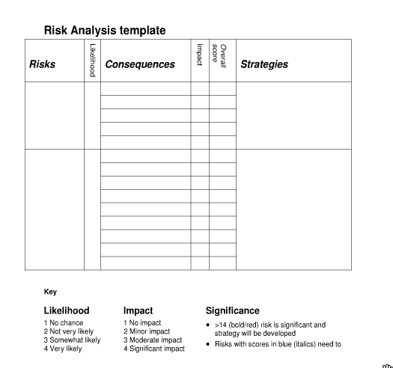

Risk | Consequence | How you will address it
Product demand doesn’t materialize | Revenue target won’t be met; lose staff | Monitor market segments and clients  Create specific customer profiles that can guide marketing and communications programs  Review current marketing program
No full-time product expert in the management team | Product development will be jeopardized if the freelance consultant decides to stop working with us | Get a marketing expert on the team who can lead implementation
Product, location are ready but don’t have marketing and promotional materials | We won’t get a broad reach for our product launch | Identify the materials, tools, and technology needed to come up with a website and set up social media platforms
New law may be passed that will add more restrictions to our product | We have to redesign our product | Assess the potential changes to be made to our production process
Competitors might copy our product | We lose our unique position in the market | Improve customer relationships and service so that even if similar products arise, people will prefer us because of how well we treat them.

Financial plan
Refer to the session on financial planning last Jan. 26 for what exactly needs to be submitted for the financial plan. The most important objective of this section is to provide information on the following:

- What are the most important costs in your business model?
- Revenue model / Pricing
  - What are your pricing model/ tactics? What do you think your customers will be willing to pay for your service/product?
- How much money will it cost to open your business?
- Annual income projections

(optional) Appendix
For class purposes, this is not so important as the other sections of the business plan. If you wish, you may add here any copies of market study material and other data used to develop elements in the business plan. You can also Include product concept skecthes and the like.

Other documents that are usually added here are:

- Resumes of the management team
- Letters of endorsements
- Copies of contracts and agreements
- Licenses, certifications, and other credentials

Sample business plans
There are many samples of business plans you can look up on the Internet. Here’s one: http://www.bplans.com/sample_business_plans.php#.UvOR80JdXu5

